National University of Computer and Emerging Sciences



Lab Manual

for

Programming Fundamentals

|  |  |
| --- | --- |
| Course Instructor | Mr. Owais Idrees |
| Lab Instructor(s) | Ms. Abiha Aftab  Ms. Muntaha Zaigham |
| Section | PF J |
| Semester | Fall 2021 |

Department of Computer Science

FAST-NU, Lahore, Pakistan

# INTRODUCTION

**WHILE LOOP:**

A **while** loop statement repeatedly executes a target statement as long as a given condition is true.

## Syntax

The syntax of a while loop in C++ is −

while(condition) {

statement(s);

}

Here, **statement(s)** may be a single statement or a block of statements. The **condition** may be any expression, and true is any non-zero value. The loop iterates while the condition is true.

When the condition becomes false, program control passes to the line immediately following the loop.

## Flow Diagram

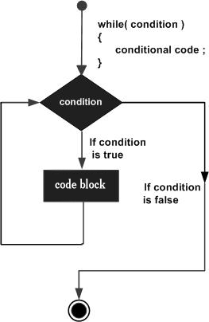

Here, key point of the *while* loop is that the loop might not ever run. When the condition is tested and the result is false, the loop body will be skipped and the first statement after the while loop will be executed.

# Lab Manual 05

**Problem 1:**

Write a program that display alphabets from A to Z using while loop

## Problem 2:

Write a program that input a number from user and display its factorial of the number using while and while loop.

Problem 3**:**

Write a program that input a number from user and display table of that number using while loop.

## Problem 4:

**Write a program that prints all odd positive number less than 100 skipping those that are exactly divisible than 7 using while loop.**

**Problem 5:**

Write a number to calculate and display the sum of following series using while loop.

x + x2 + x4 + …….. + xn

**Hint:**

Used **pow(x,i)** function for power

**Output:**

Enter a number : 5

Enter a value n : 5

Sum =655

## Problem 6:

Write a program to display a table of equivalent temperature in Fahrenheit and Celsius from 50F TO 100F with an increment 5 by using while loop.

**Formula :**

C = 5/9 * (f-32)

**Output :**

**Fahrenheit**  **Celsius**

50 10.00

55 12.78

60 15.56

65 18.33

70 21.11

.

.

.

.

100 37.78

## Problem 6:

**Problem 7:**

Write a program that displays the following using while loop.

**Output:**

4 4 4 4

3 3 3

2 2

1